Call for projects application
How to send your application form

The form must be in “word” format (no PDF files) and in a single file.

Please note that all fields must be filled in in order for your application to be considered.
Title of the project:

Purpose of the project:

Applicant organization:

Date of submission of the application:

- INTRODUCTION

In 2022, the Fondation Vilebrequin launched its call for project initiative which seeks to contribute to one of the three pillars of the foundation
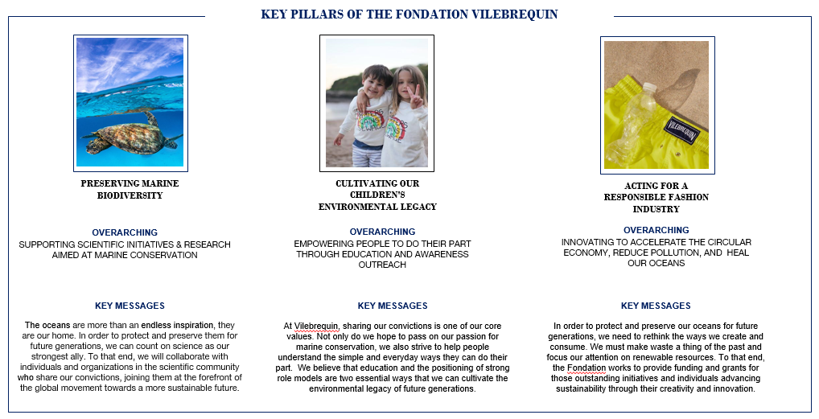
This call for project is aimed at any organization that shares the values of the Fondation Vilebrequin and proposes practical actions to preserve marine biodiversity, a less polluting fashion industry and a more educated planet on sustainable issues.
In order to process your application, we kindly ask you to fill in the form starting on section 2 of this document.
If the proposal is in line with our criteria and priorities, we will follow up and ask for further information in due course. Please note that the final decision on the selection of projects will be taken by the foundation board on a quarterly basis.

Who is eligible for the fund?
- a not-for-profit organization
- a start-up aiming for a more sustainable future
- a charitable organization working in the public interest

Who’s not eligible?
- Individuals
- For profit,
- Promotional or advertising purposes;
- End-of-studies, university theses or dissertations;
- Publishing a book or film; of a personal nature, such as a trip, a world tour, participation in a rally, etc.
- Events (festivals, meetings, green classes, etc.).
What we finance:
Projects should fall within one of our three key pillars.
We value the willingness to promote local actions with concrete impacts.
Variety and multitude of projects will be financed in the range of 1’000 CHF to 30’000 CHF.

- IDENTITY OF THE APPLICANT
- Company name (in full) :
- Main activity :

- Creation date :
- Numbers of employees :
- Other staff, specify (volunteers, apprentices, etc.):

- Name of the representative :
- Position of the representative :
- Headquarters address :

- Contact postal address (if different) :

- Contact phone number :
- Contact email :

- DESCRIPTION OF THE PROJECT
  - Person responsible of the project
Name:
Position within your organization:
Specify your skills in relation to the project:

  - Presentation of the project
Specify project’s location, in which countries will you have an impact and local actions:

Planned start and end dates, duration in months:

Context: why are you proposing this project, what are the issues you are addressing?

Please indicate in which pillar of the foundation this project applies:
PRESERVING MARINE BIODIVERSITY ☐

CULTIVATING OUR CHILDREN’S ENVIRONMENTAL LEGACY ☐

ACTING FOR A RESPONSIBLE FASHION INDUSTRY ☐

Purpose of the project:

Summary of the project in a few lines:

Project beneficiaries:

- Summary of actions and expected results
Please complete the following table.
Each line A1, A2, etc. corresponds to an action planned as part of your project. In the "Activities" column, fill in the different actions planned. In the "Timetable" column, specify the expected implementation time (start and end). Example: March to April 2022, 15th June 2022... In the "Target results and deliverables" column, indicate the expected results.

Activities | Implementation schedule | Expected results and deliverables
A1 :  A2 :  A3 :  … | A1 :  A2 :  A3 :  … | A1 :  A2 :  A3 :  …

- Human and material resources
List the people and structures involved in the project and describe their respective contribution:

Describe the material resources needed for your project, whether they are already in your possession or whether they will be acquired for the project.

- Budget and expected support

- Overall budget for the project :
- Total amount sought :
- Self-financing amount :

- Do you have any other financial partners? YES ☐ NO ☐
- If yes, who? Please indicate their contributions

In the "Activities" column, list the actions described in section 4. In the column "Estimated budget", fill in the planned budget for each action. In the "Expenditure type" column, specify the different categories of expenditure for each action. Use the "Project Management" line for the budget corresponding to the overall project costs, not linked to a specific action. Example: travel.

Activities (see 3.) | Estimated budget in euros | Expenditure type (examples)
A1
A2
A3
Project management
TOTAL EXPENSES

- End of the project
How will you evaluate the success of your project?

Are there any plans for follow-up at this stage?

Do you think it is possible to roll out or replicate your project on a larger scale?

- Miscellaneous
Any other information you may wish to add

- Application and commitment

I, the undersigned, (Surname, First name) : ……………………………………………………………………
acting as :………………………………………………………………………………
- requests financial assistance for the realization of the project which is the subject of this application

- hereby certify the accuracy of the information provided,

- hereby certify to be in compliance in regards to all social and tax filings,

- hereby certify to be committed in respecting the regulatory obligations, in particular to obtain the administrative authorizations necessary for the implementation of the operation,

- hereby certify that the operation which is the subject of this application for funding does not relate to an operation that has been imposed by the administrative authority as a result of a formal notice or conviction, or as a compensatory measure,

- hereby certify not to be in a state of judicial liquidation, receivership or personal bankruptcy,

Place : ........................................, Date .........................

The applicant (signature and stamp)

Once your application has been reviewed, we might require additional information as listed below.
In that case, please send those documents to: fondation@vilebrequin.com with the subject email being “Documents for call for projects application” along with all the required documents.

- List of documents to be attached
☐ ID of the legal representative
☐ Business Registration Number
☐ JO (Journal Official) registration
☐ Civil liability insurance
☐ Quotes for the project expenses
☐ Profit and loss accounts and balance sheets for the last 2 accounting years approved
☐ Bank Account Details
☐ Statutes for Associations and Cooperatives
☐ Proof of participation of financial partners (letters, contracts…)
☐ Any document attesting to an environmental commitment: certificate, label

